Set up a VPC with an Internet gateway, create a public subnet with 256 IP addresses, a private subnet with 256 IP addresses, make a route table connecting the Internet gateway and the subnets, and launch a Linux EC2 instance by using the above VPC and public subnet.

Create a vpn

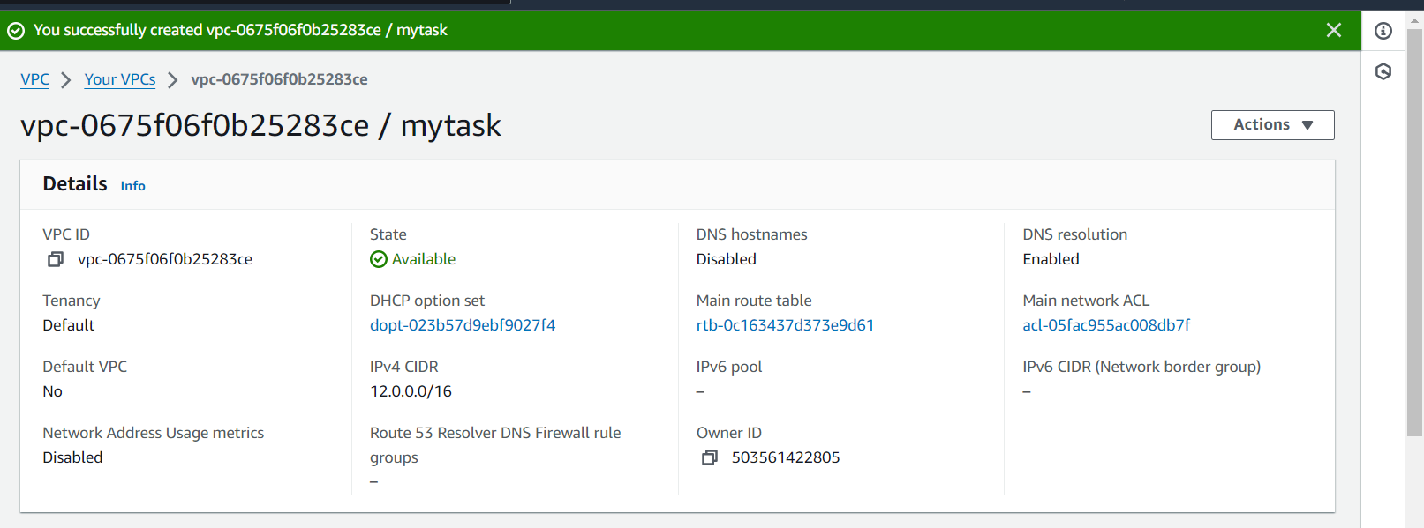

Create a internet gateway

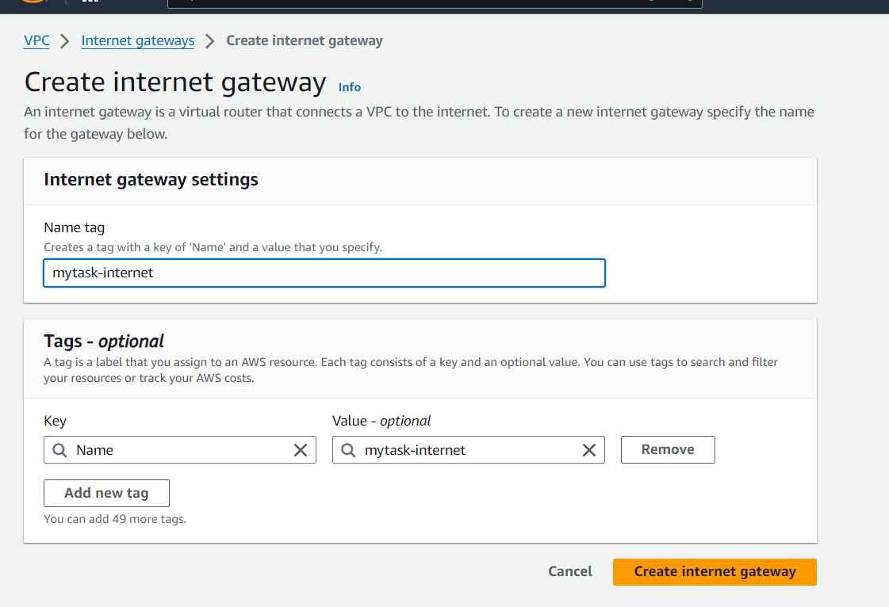

Internet gate attached to vpc

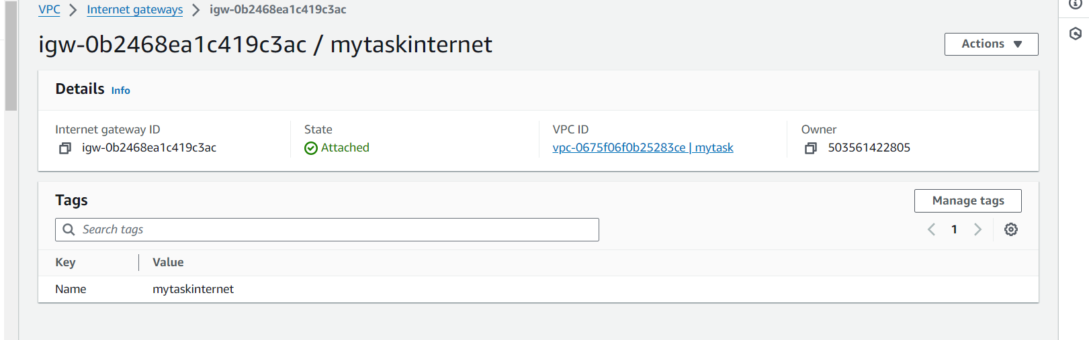

Create subnet for public and private

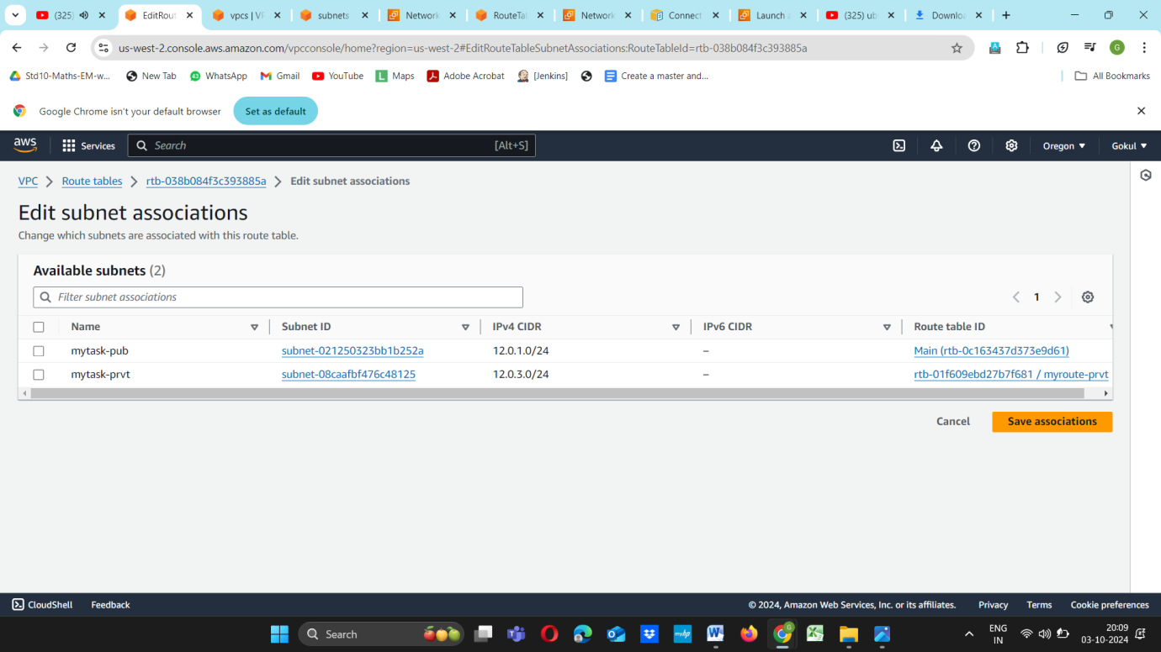

Now create a route table for both public and private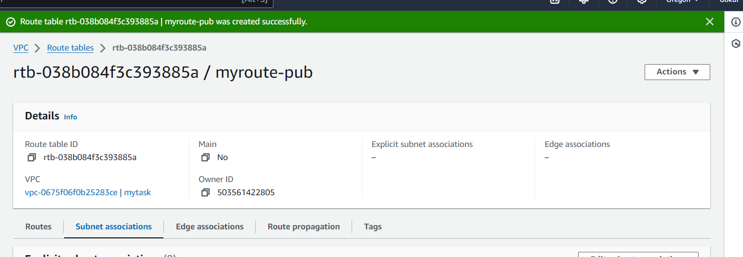

Public route connected to internat gate

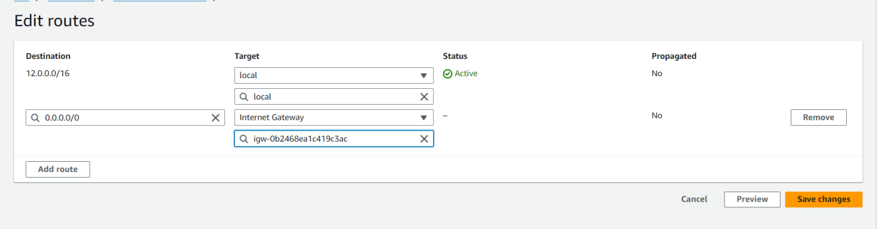

Finally public server active